Lab 5 Report

Task 1

Task 1 showed the use of frequency analysis against a monoalphabetic cipher.

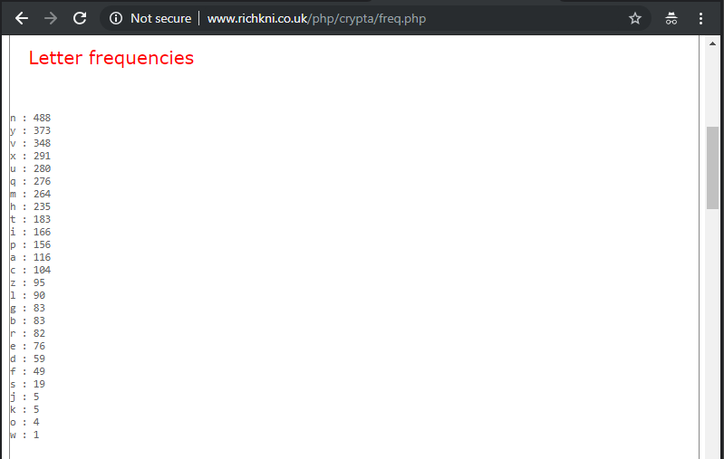

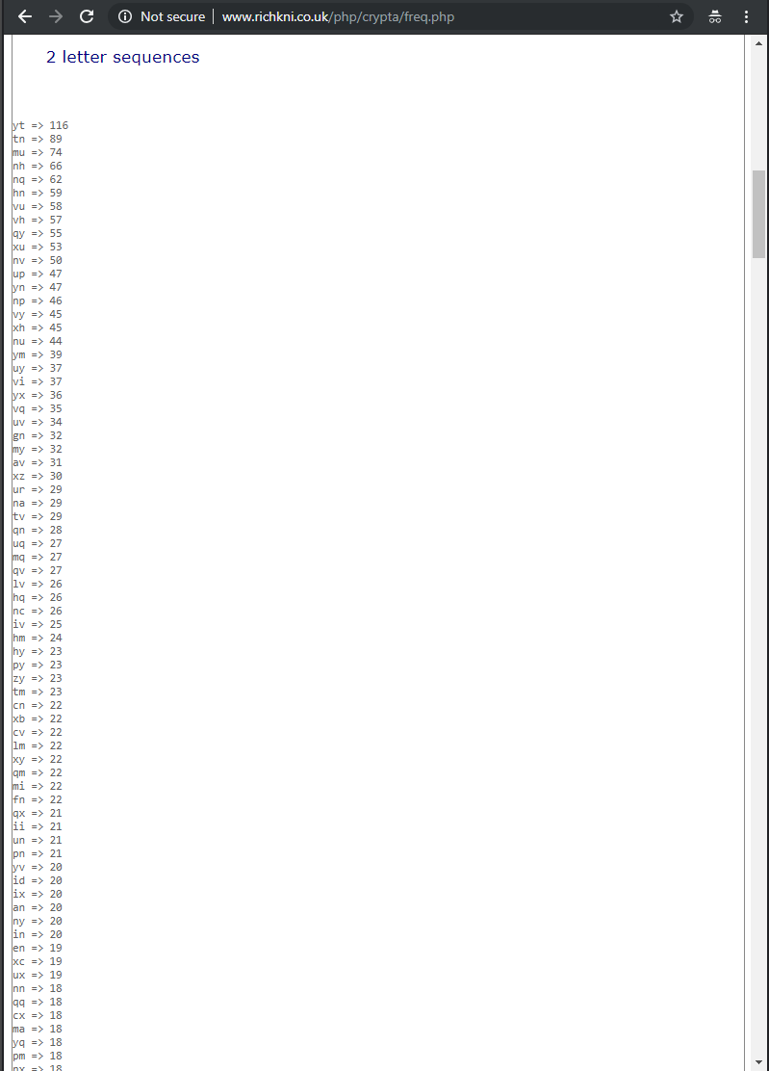

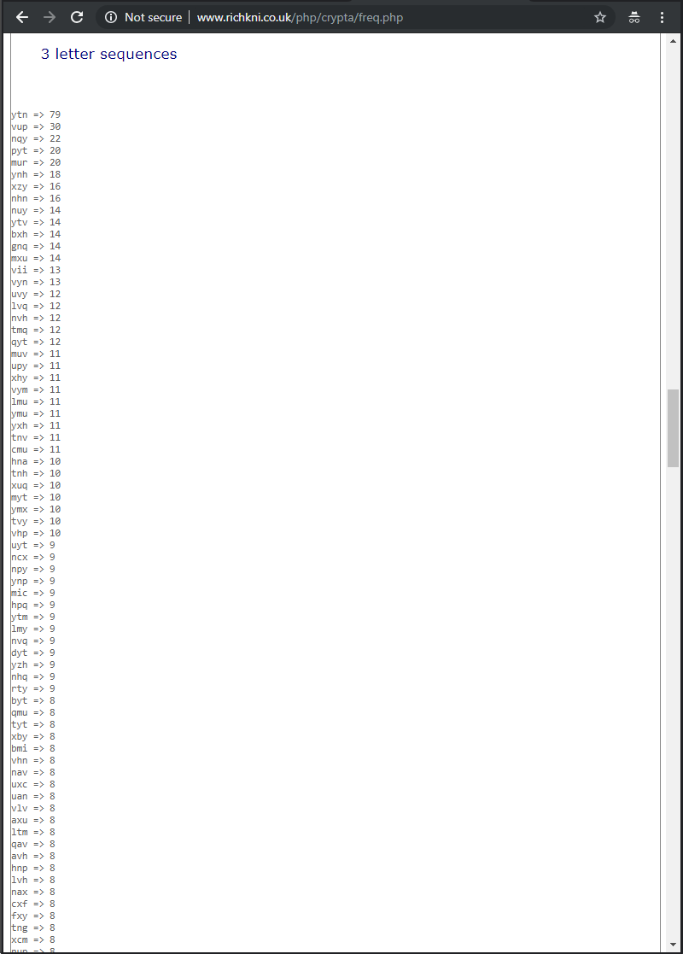

Observation: The screenshots above show a sample of the frequency analysis data that was obtained by using <http://www.richkni.co.uk/php/crypta/freq.php> for the ciphertext.

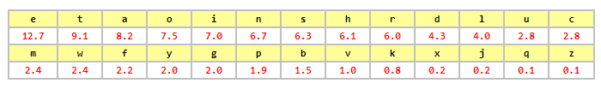

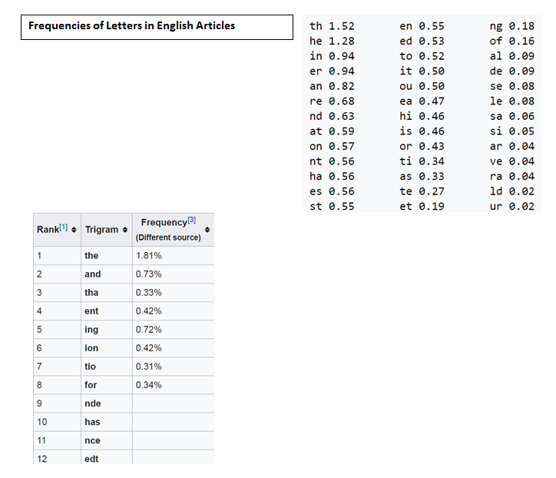

Observation: The screenshots above show frequencies of letters in English articles. The frequencies of letters in English articles were used along with the frequency analysis data obtained from the ciphertext to determine the encryption key. 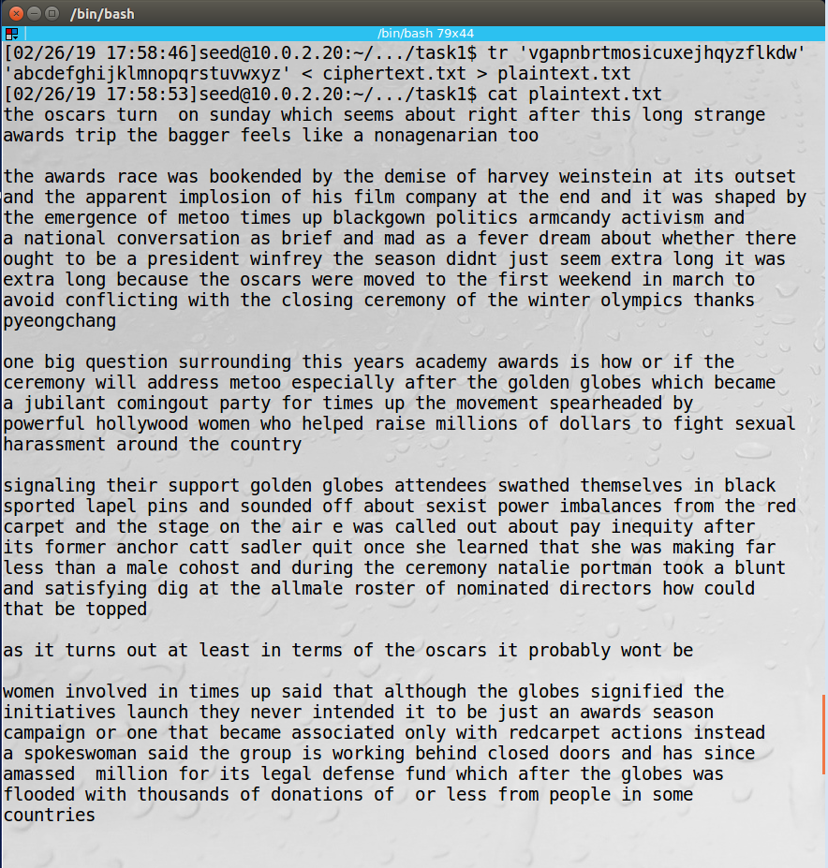





Observation: The screenshots above show “vgapnbrtmosicuxejhqyzflkdw” was used as the encryption key. The “tr” command was used to convert the ciphertext to plaintext and the output was sent to a file. The “cat” command was used to output the file.

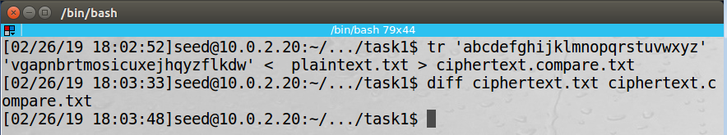

Observation: The screenshot above shows the “tr” command was used to convert the plaintext back to ciphertext and the output was sent to a file. The “diff” command was used to compare the file with the original ciphertext.

Explanation: The ciphertext from a monoalphabetic cipher can be subjected to frequency analysis to determine the plaintext. In this task, the frequencies of letters in English articles were used along with the frequency analysis data obtained from the ciphertext to determine the encryption key.

Task 2

This task showed the use of different ciphers and modes.

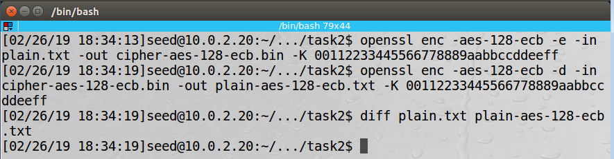

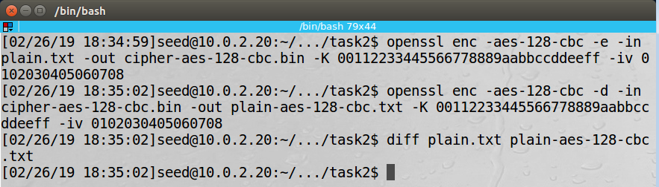

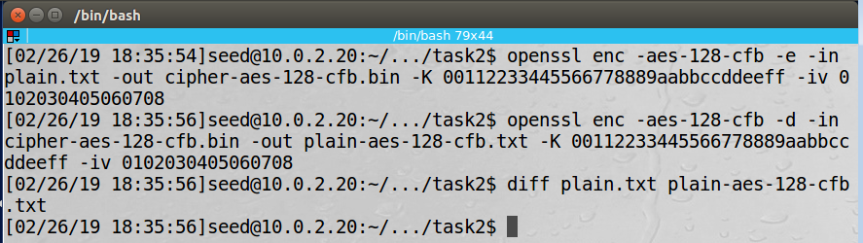

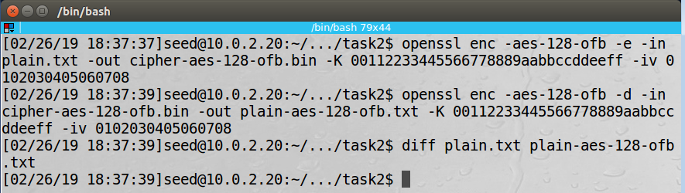

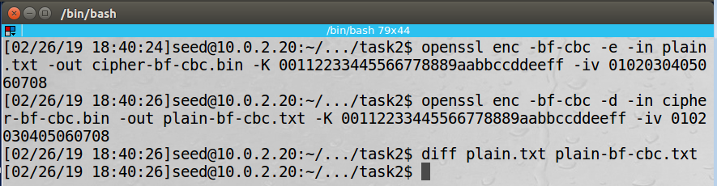

Observation: The screenshots above show encryption and decryption using the following cipher types:

* aes-128-ecb
* aes-128-cbc
* aes-128-cfb
* aes-128-ofb
* bf-cbc

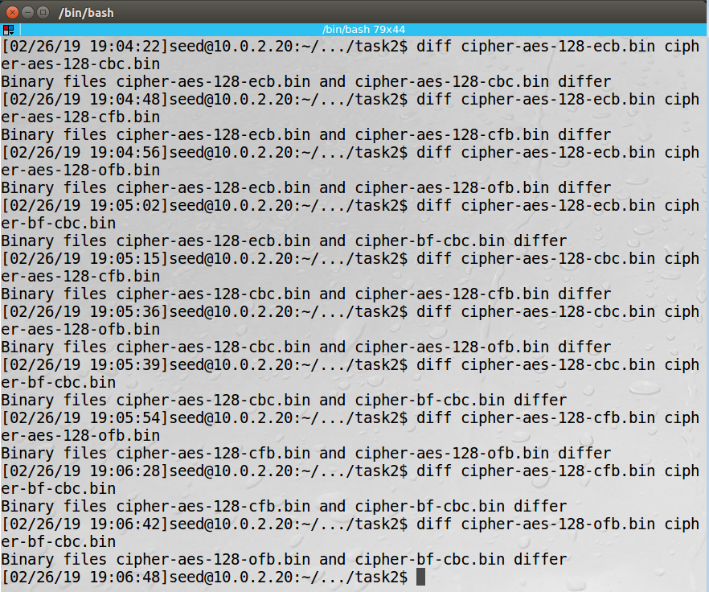

Observation: The screenshot above shows each cipher type produced a different result.

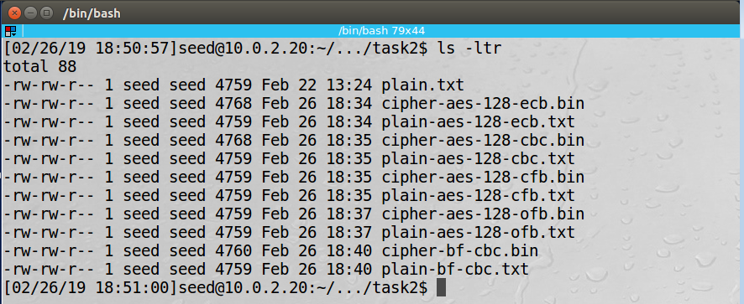

Observation: The screenshot above shows the size of the files with ciphertext compared with the size of the files with plaintext. The ECB and CBC ciphers are block ciphers, so their ciphertext file was padded out to a multiple of the block size. AES-128 has a block size of 128 bits (16 bytes) and Blowfish has a block size of 64 bits (8 bytes). The size of the ciphertext file for AES-128 ECB and AES-128 CBC was 4768 bytes, which is a multiple of 16. The size of the ciphertext file for Blowfish was 4760 bytes, which is a multiple of 8. The CFB and OFB ciphers are stream ciphers, so their ciphertext file was the same size as the plaintext file.

Explanation: Different cipher types can produce files with different results and sizes. This task showed the results of encryption using a variety of cipher types. Each of the cipher types produced a different result. It was demonstrated that block ciphers pad the encrypted file to be a multiple of the block size and stream ciphers don’t pad the encrypted file. It was also demonstrated that different block sizes produce different file sizes for block ciphers.

Task 3

This task showed the results of using ECB and CBC on a bitmap file.

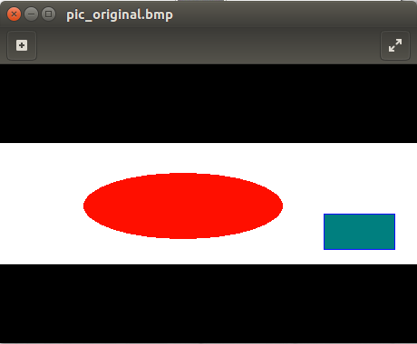

Observation: The screenshot above shows the original bitmap picture.

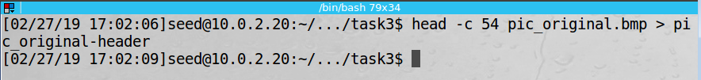

Observation: The screenshot above shows the header of the original bitmap file saved to a new file.

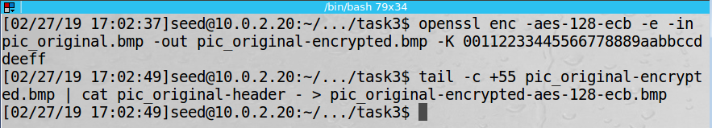

Observation: The screenshot above shows the use of AES-128 ECB encryption on the original bitmap file. The first 54 bytes of the encrypted bitmap file were replaced with the header from the first 54 bytes of the original bitmap file using the “tail” and “cat” commands.

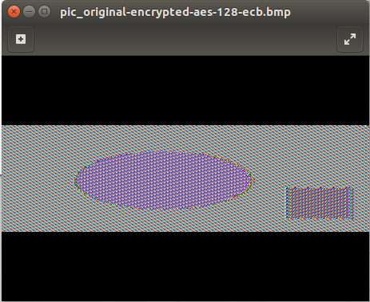

Observation: The screenshot above shows the result of using AES-128 ECB encryption. Note that the pattern from the original file can still be seen.

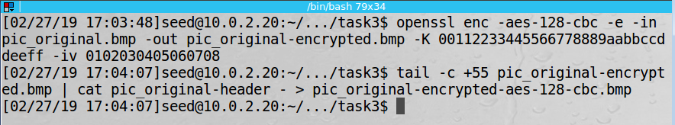

Observation: The screenshot above shows the use of AES-128 CBC encryption on the original bitmap file. The first 54 bytes of the encrypted bitmap file were replaced with the header from the first 54 bytes of the original bitmap file using the “tail” and “cat” commands.

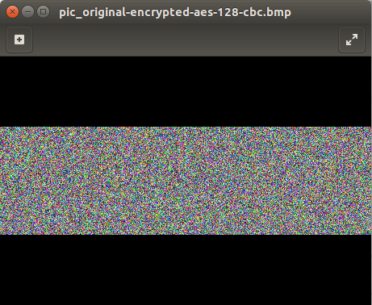

Observation: The screenshot above shows the result of using AES-128 CBC encryption. Note that the pattern from the original file cannot be seen.

Observation: The screenshot above shows the original bitmap picture I chose.

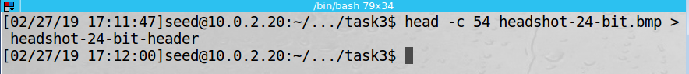

Observation: The screenshot above shows the header of the original bitmap file saved to a new file.

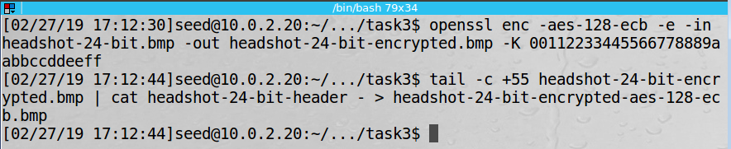

Observation: The screenshot above shows the use of AES-128 ECB encryption on the original bitmap file. The first 54 bytes of the encrypted bitmap file were replaced with the header from the first 54 bytes of the original bitmap file using the “tail” and “cat” commands.

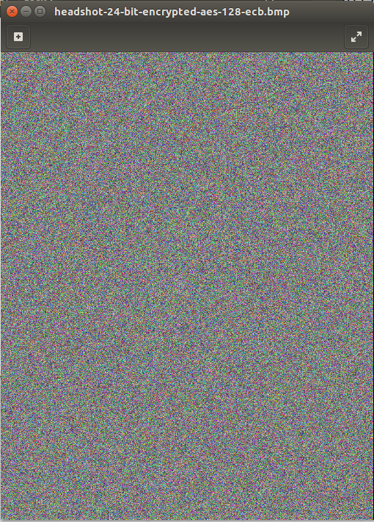

Observation: The screenshot above shows the result of using AES-128 ECB encryption. Note that the pattern from the original file cannot be seen. This is because the different colors in the picture didn’t have many duplicate blocks that would encrypt to the same result.:-)☺☺

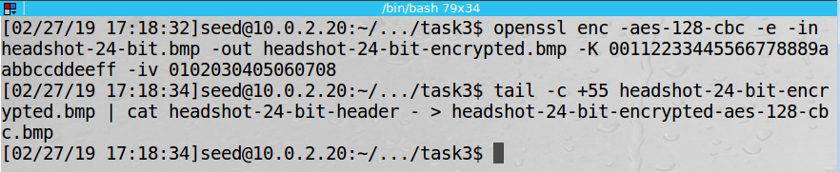

Observation: The screenshot above shows the use of AES-128 CBC encryption on the original bitmap file. The first 54 bytes of the encrypted bitmap file were replaced with the header from the first 54 bytes of the original bitmap file using the “tail” and “cat” commands.

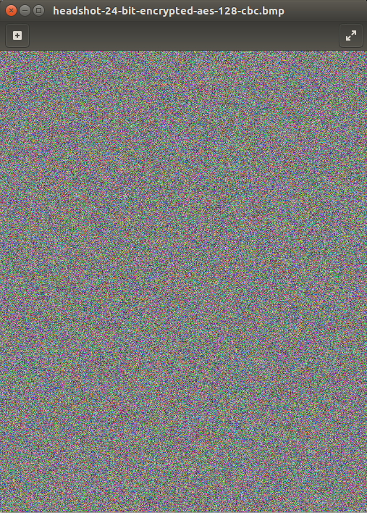

Observation: The screenshot above shows the result of using AES-128 CBC encryption. Note that the pattern from the original file cannot be seen.

Observation: The screenshot above shows the result of some modifications I made to my original picture. I saved my picture as a monochrome bitmap file and then I saved that file as a 256 color bitmap file. This was an attempt to create duplicate blocks that would encrypt to the same result.

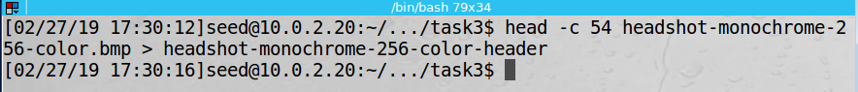

Observation: The screenshot above shows the header of the original bitmap file saved to a new file.

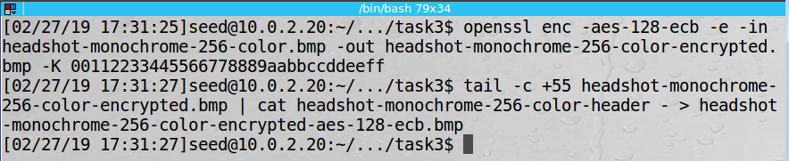

Observation: The screenshot above shows the use of AES-128 ECB encryption on the original bitmap file. The first 54 bytes of the encrypted bitmap file were replaced with the header from the first 54 bytes of the original bitmap file using the “tail” and “cat” commands.

Observation: The screenshot above shows the result of using AES-128 ECB encryption. Note that the pattern from the original file can still be seen.:-), great experiment!! +2

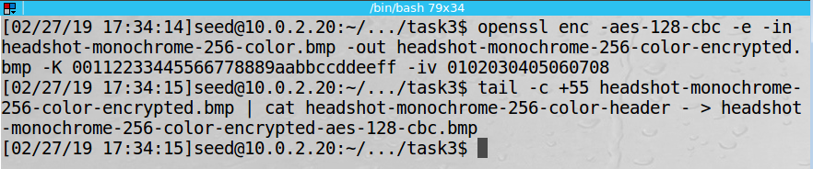

Observation: The screenshot above shows the use of AES-128 CBC encryption on the original bitmap file. The first 54 bytes of the encrypted bitmap file were replaced with the header from the first 54 bytes of the original bitmap file using the “tail” and “cat” commands.



Observation: The screenshot above shows the result of using AES-128 CBC encryption. Note that the pattern from the original file cannot be seen.

Explanation: The problem with ECB encryption is that identical plaintext blocks are encrypted into identical ciphertext blocks, so it doesn’t hide patterns well. This task demonstrated that problem. The CBC encryption helps solve this problem by using the ciphertext from the prior block XORed with the plaintext of the current block as an input to the block cipher encryption to produce the ciphertext for the current block.

Task 5

This task showed how a single bit error in an encrypted file would impact the results when the file is decrypted. Effects for ECB, CBC, CFB, and OFB were examined.

When referencing byte numbers and block numbers, byte numbering and block numbering starts at 1. Note that the 55th byte will be in Block 4 in the file. Here are my expectations prior to conducting the task.

Electronic Codebook (ECB) Mode

In ECB decryption, each block is decrypted separately without using any results from other blocks. A change in one bit in the 55th byte in the encrypted file will result in only Block 4 being corrupted when the file is decrypted. All bytes in Block 4 will be corrupted.

Cipher Block Chaining (CBC) Mode

In CBC decryption, the ciphertext from the prior block is XORed with the result of block cipher decryption of the ciphertext of the current block to produce the plaintext for the current block. A change in one bit in the 55th byte in the encrypted file will result in Block 4 and Block 5 being corrupted when the file is decrypted. All bytes in Block 4 will be corrupted. A single bit in Block 5 will be corrupted.

Cipher Feedback (CFB) Mode

In CFB decryption, the ciphertext from the prior block is passed through block cipher decryption and the result is XORed with the ciphertext of the current block to produce the plaintext for the current block. A change in one bit in the 55th byte in the encrypted file will result in Block 4 and Block 5 being corrupted when the file is decrypted. A single bit in Block 4 will be corrupted. All bytes in Block 5 will be corrupted.

Output Feedback (OFB) Mode

In OFB decryption, the data after block cipher decryption and before the XOR from the prior block is passed through block cipher decryption and the result is XORed with the ciphertext of the current block to produce the plaintext for the current block. A change in one bit in the 55th byte in the encrypted file will result in only Block 4 being corrupted when the file is decrypted. A single bit in Block 4 will be corrupted.

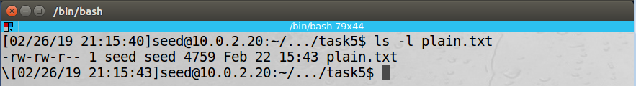

Observation: The screenshot above shows the text file was greater than 1000 bytes.

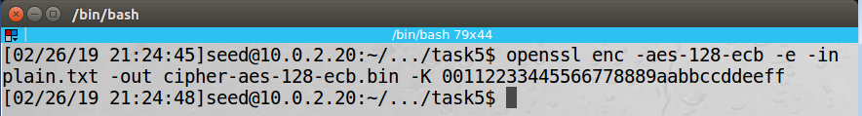

Observation: The screenshot above shows encryption being performed using AES-128 ECB.

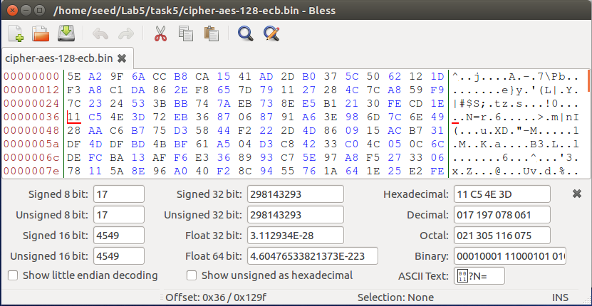

Observation: The screenshot above shows the encrypted file before introducing a single bit error.

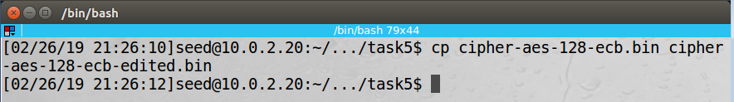

Observation: The screenshot above shows the encrypted file was copied to another file to be edited.

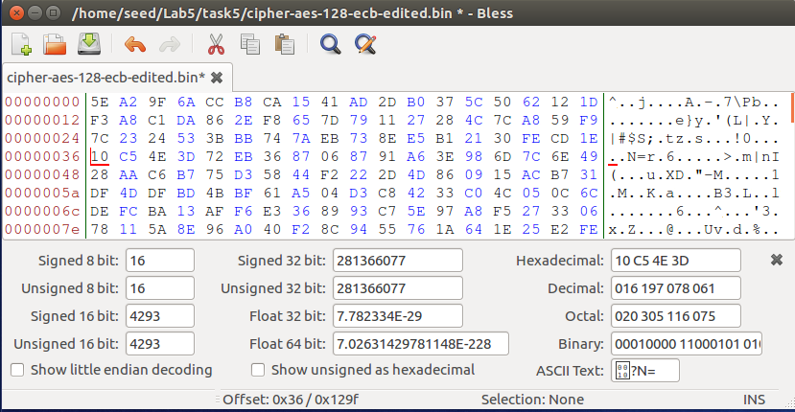

Observation: The screenshot above shows a single bit error that changed the 55th byte from 0x11 to 0x10. The 55th byte is in offset 0x36 in the screenshot. The file was saved.

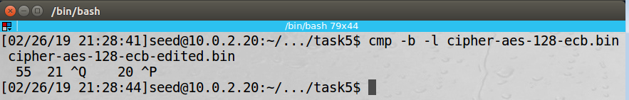

Observation: The screenshot above shows the “cmp” command used to show the single bit error.

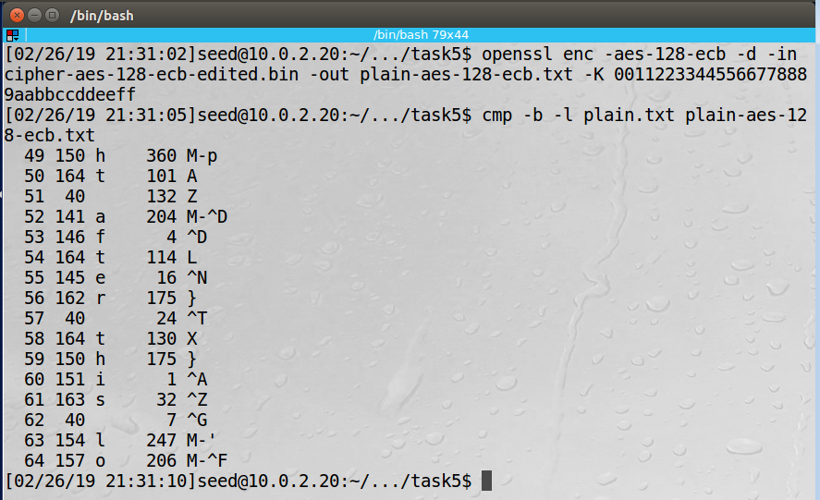

Observation: The screenshot above shows the decryption of the file with the single bit error and the comparison with the original file. Block 4 in the file contains bytes 49 through 64. The comparison shows all bytes in Block 4 were corrupted. Nice compare!!

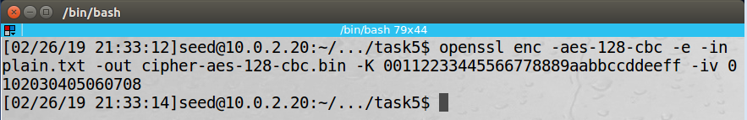

Observation: The screenshot above shows encryption being performed using AES-128 CBC.

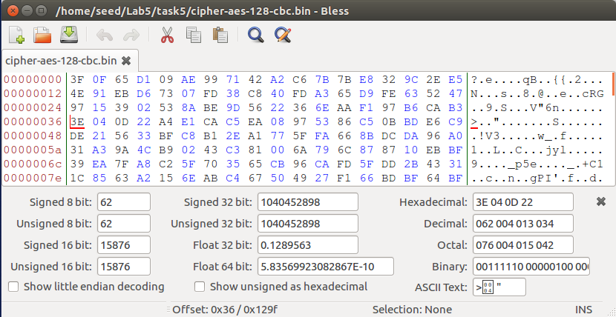

Observation: The screenshot above shows the encrypted file before introducing a single bit error.

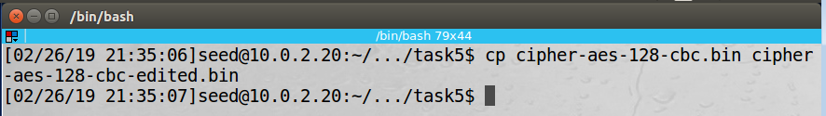

Observation: The screenshot above shows the encrypted file was copied to another file to be edited.

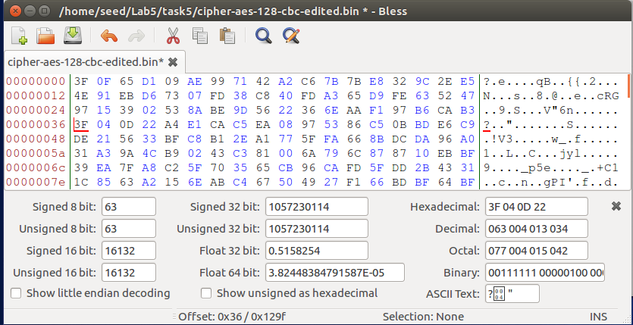

Observation: The screenshot above shows a single bit error that changed the 55th byte from 0x3E to 0x3F. The 55th byte is in offset 0x36 in the screenshot. The file was saved.

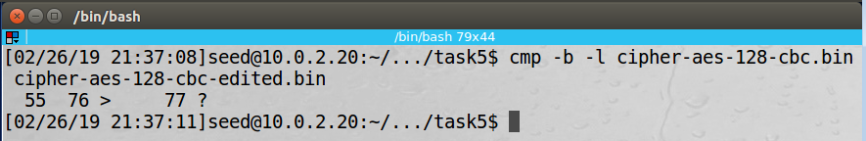

Observation: The screenshot above shows the “cmp” command used to show the single bit error.

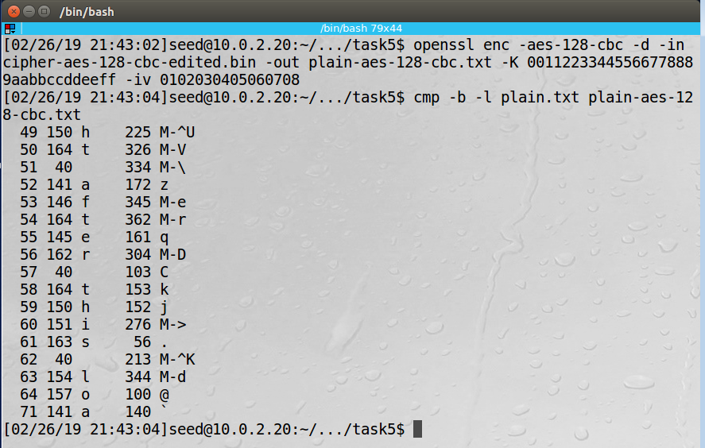

Observation: The screenshot above shows the decryption of the file with the single bit error and the comparison with the original file. Block 4 in the file contains bytes 49 through 64. Block 5 in the file contains bytes 65 through 80. The comparison shows all bytes in Block 4 were corrupted and a single bit in Block 5 was corrupted. Note that the byte with a single bit error in the encrypted file is the 7th byte in its block and the byte with the single bit error in Block 5 in the decrypted file is the 7th byte in its block.

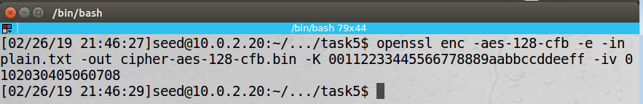

Observation: The screenshot above shows encryption being performed using AES-128 CFB.

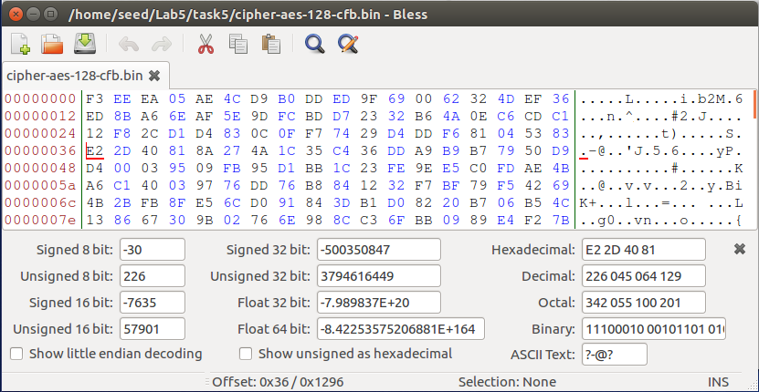

Observation: The screenshot above shows the encrypted file before introducing a single bit error.

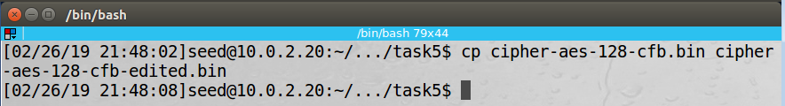

Observation: The screenshot above shows the encrypted file was copied to another file to be edited.

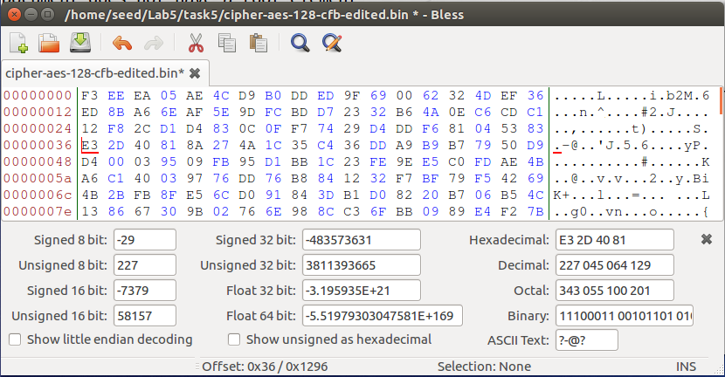

Observation: The screenshot above shows a single bit error that changed the 55th byte from 0xE2 to 0xE3. The 55th byte is in offset 0x36 in the screenshot. The file was saved.

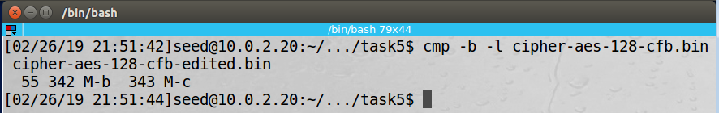

Observation: The screenshot above shows the “cmp” command used to show the single bit error.

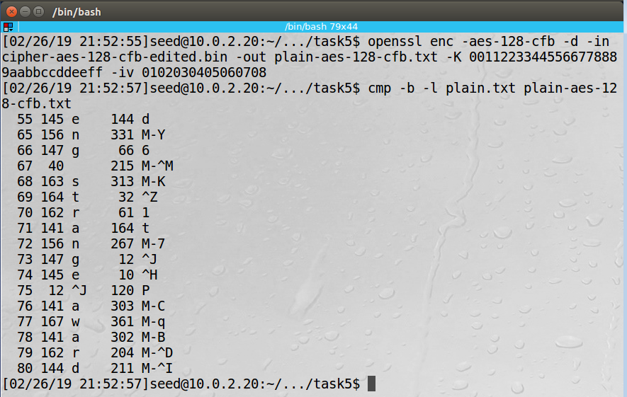

Observation: The screenshot above shows the decryption of the file with the single bit error and the comparison with the original file. Block 4 in the file contains bytes 49 through 64. Block 5 in the file contains bytes 65 through 80. The comparison shows a single bit in Block 4 was corrupted and all bytes in Block 5 were corrupted. Note that the byte with a single bit error in the encrypted file is the 7th byte in its block and the byte with the single bit error in Block 4 in the decrypted file is the 7th byte in its block.

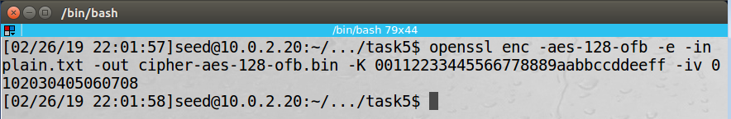

Observation: The screenshot above shows encryption being performed using AES-128 OFB.

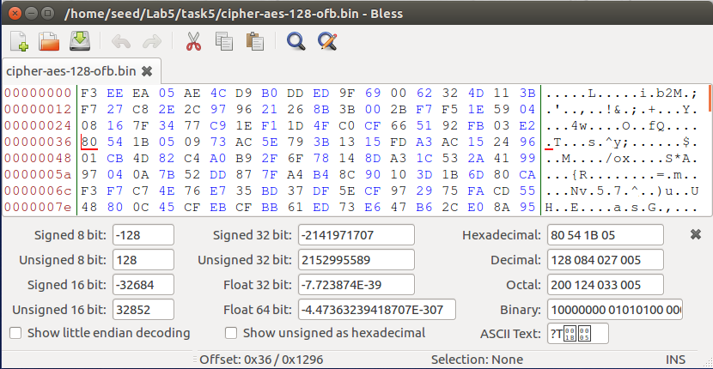

Observation: The screenshot above shows the encrypted file before introducing a single bit error.

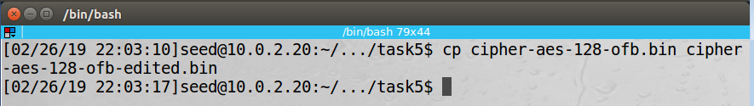

Observation: The screenshot above shows the encrypted file was copied to another file to be edited.

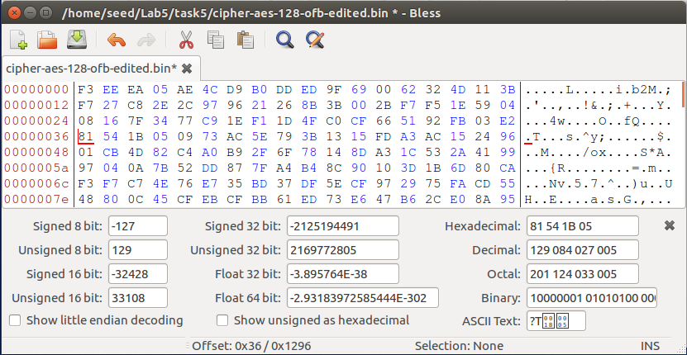

Observation: The screenshot above shows a single bit error that changed the 55th byte from 0x80 to 0x81. The 55th byte is in offset 0x36 in the screenshot. The file was saved.

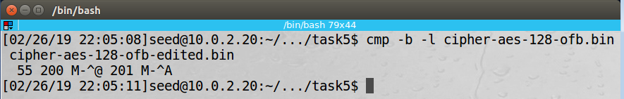

Observation: The screenshot above shows the “cmp” command used to show the single bit error.

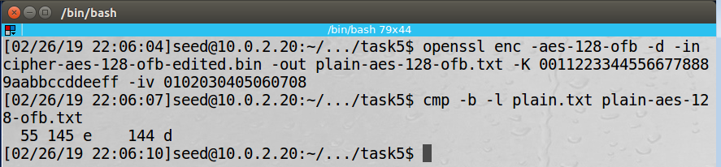

Observation: The screenshot above shows the decryption of the file with the single bit error and the comparison with the original file. Block 4 in the file contains bytes 49 through 64. The comparison shows a single bit in Block 4 was corrupted. Note that the byte with a single bit error in the encrypted file is the 7th byte in its block and the byte with the single bit error in Block 4 in the decrypted file is the 7th byte in its block.

Explanation: Single bit errors can produce different results depending on what encryption mode is selected. In this task, ECB, CBC, CFB, and OFB were examined to show the effects on decryption when a single bit error is present in an encrypted file. Effects for each of the modes are summarized below.

Electronic Codebook (ECB) Mode

In ECB decryption, each block is decrypted separately without using any results from other blocks. A change in one bit in Block N in the encrypted file will result in all bytes in Block N in the decrypted file being corrupted.

Cipher Block Chaining (CBC) Mode

In CBC decryption, the ciphertext from the prior block is XORed with the result of block cipher decryption of the ciphertext of the current block to produce the plaintext for the current block. A change in one bit in Block N in the encrypted file will result in all bytes in Block N and one bit in Block N+1 in the decrypted file being corrupted.

Cipher Feedback (CFB) Mode

In CFB decryption, the ciphertext from the prior block is passed through block cipher decryption and the result is XORed with the ciphertext of the current block to produce the plaintext for the current block. A change in one bit in Block N in the encrypted file will result in one bit in Block N and all bytes in Block N+1 in the decrypted file being corrupted.

Output Feedback (OFB) Mode

In OFB decryption, the data after block cipher decryption and before the XOR from the prior block is passed through block cipher decryption and the result is XORed with the ciphertext of the current block to produce the plaintext for the current block. A change in one bit in Block N in the encrypted file will result in one bit in Block N in the decrypted file being corrupted.